|  |  |  |  |  |  |  |
| --- | --- | --- | --- | --- | --- | --- |
| Тема | Задатак | 2011 | Тип публ. | Број публ. | Извршиоци | Носилац |
| 5 | 1. Реализација хардверског слоја виртуелног инструмента | х | М61 | 1 | М. Димитријевић | В. Литовски |
|  | 2. Реализација софтвера виртуелног инструмента укјључујући и генерисање и манипулацију базом мерења као и графичке презентације | х | М61 | 1 | М. Димитријевић | В. Литовски |
|  | 3. Портовање на real-time оперативни систем | х |  |  | М. Димитријевић | В. Литовски |
|  | 4. Прилагођење функције хардверског слоја виртуелног инструмента за уградњу новопројектованог мерног интегрисаног кола. | х | М51,М23 | 2 | М. Димитријевић | В. Литовски |

# Virtual instrument for harmonic distortion analysis in power grid

Power quality analysis is related to measurement of power factor and total harmonic distortion. In linear circuits, consisting of linear loads, the currents and voltages are sinusoidal and the power factor effect arises only from the difference in phase between the current and voltage. In single phase system it is referred as the displacement power factor or cos(φ) [1]. The power concepts developed for single-phase circuits with sinusoidal voltages and currents can be extended to polyphase circuits. Such circuits can be considered to be divided into a group of two-wire sets, with the neutral conductor (or a resistively derived neutral for the case of a delta-connected, three wire circuit) paired with each other conductor [2].

When nonlinear loads are present one should introduce new quantities in the calculations emanated by the harmonics and related power components [3]. Now the power factor can be generalized to a total or true power factor where the apparent power, involved in its calculations, includes all harmonic components. This is of importance in characterization and design of practical power systems which contain non-linear loads such as switched-mode power supplies [4].

Electronic loads are strongly related to the power quality thanks to the implementation of switched-mode power supplies that in general draw current from the grid in bursts. In that way, while keeping the voltage waveform almost unattached, they impregnate pulses into the current so chopping it into seemingly arbitrary waveform and, consequently, producing harmonic distortions [5]. The current-voltage relationship of these loads, looking from the grid side, is nonlinear, hence nonlinear loads. The existence of harmonics gives rise to interference with other devices being powered from the same source and, having in mind the enormous rise of the number of such loads, the problem becomes serious with serious, sometimes damaging, consequences and has to be dealt with properly.

Power factor and distortion measuring usually requires dedicated and expensive equipment. PC-based virtual instrument for one phase power factor and distortion analysis with National Instruments data acquisition module was developed as alternative to traditional instruments [6]. In this paper we will present new approach to power factor and distortion analysis in polyphase systems. This solution is based on Xilinx Virtex II field programming gate array (FPGA), National Instruments NI9225 and NI9227 acquisition modules and PXI controller running real-time operating system (RTOS). It brings all advantages of virtual instrumentation, preserving reliability and real time capabilities of traditional, standalone instrument. Virtual instrument is implemented using LabVIEW software platform. It is capable for measuring and calculating various electrical, power and power quality parameters. The application is highly flexible; it can be also implemented using industrial PC or programmable automation controller (PAC).

In the next we will first introduce the basic definitions that are expressing how the measured quantities are calculated from the current and voltage waveforms according to IEEE Std 1459-2000 [7] and IEEE Std 1459-2010 [8] standards. Then, the system architecture will be described. We will introduce implementations of all subsystems and explain their roles in acquisition, data processing and presentation. Finally, we will highlight some potentials of given concept.

The system structure is shown in Fig. 1.

1

Fig. 1. The system structure

The system consists of four components:

1. acquisition subsystem;
2. FPGA;
3. PC or controller running real-time operating system (RTOS);
4. PC running general purpose operating system (GPOS).

## Hardware implementation

The acquisition and conditioning of the electrical quantities mentioned in previous section is performed by the acquisition subsystem. The subsystem is connected to the power grid from one side, and transfers the power to the load while sampling the values of the sampling of 3 voltage and 4 current signals (Fig. 2). Modules for signal conditioning of voltage and current waveforms provide attenuation, isolation and anti-aliasing. The sampled values are appropriately conditioned, and then directly delivered to the FPGA.

Figure 2

Fig. 2. Connection diagram

Acquisition subsystem is based on National Instruments cRIO-9151 expansion chassis, providing hot-plug module connectivity [9]. The chassis is equipped with two data acquisition modules: NI9225 and NI9227.

NI9225 has three channels of simultaneously sampled voltage inputs with 24-bit accuracy, 50 kSa/s per channel sampling rate and 600 VRMS channel-to-earth isolation, suitable for voltage measurements up to 100th harmonic (5 kHz). The 300 VRMS range enables line-to-neutral measurements of 240 V power grids [10].

NI9227 is four channels input module with 24-bit accuracy, 50 kSa/s per channel sampling rate, designed to measure 5 ARMS nominal and up to 14 A peak on each channel with 250 VRMS channel-to-channel isolation [11].

The FPGA provides timing, triggering control and channel synchronization maintaining high-speed, hardware reliability and strict determinism.

In this application, Xilinx Virtex II FPGA is used. The FPGA is placed on National Instruments PXI-7813R card embedded into NI-8014 PXI controller. Interface connecting controller and FPGA is PCI.

The FPGA code is implemented in LabVIEW development environment; it runs two parallel loops with executing period of 20 ms. First loop determines fundamental signal frequency, performs FFT analysis (fig. 3) and calculates RMS values of acquired current and voltage signals, harmonic magnitudes and phases.

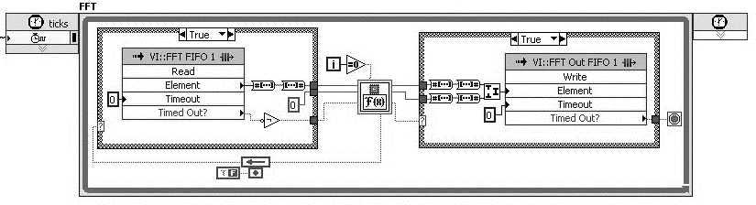

Fig. 3. FFT loop running on FPGA

Second loop transfers calculated data to next processing level, real time subsystem, over DMA FIFO channel.

## Software implementation

The real time subsystem is PXI controller or PC running PharLap real time operating system and real time multithread application which represent second data processing stage. Application consists of for threads.

First tread receives data from FPGA and calculates power quantities: apparent power, active power, reactive power and energy. Second thread calculates power quality parameters including total harmonic distortion (*THD*I, *THD*V), crest factors, total power factor and displacement power factor (fig. 4.). Third thread detects events such as voltage dips, swells, and interruptions, flicker and system unbalance.

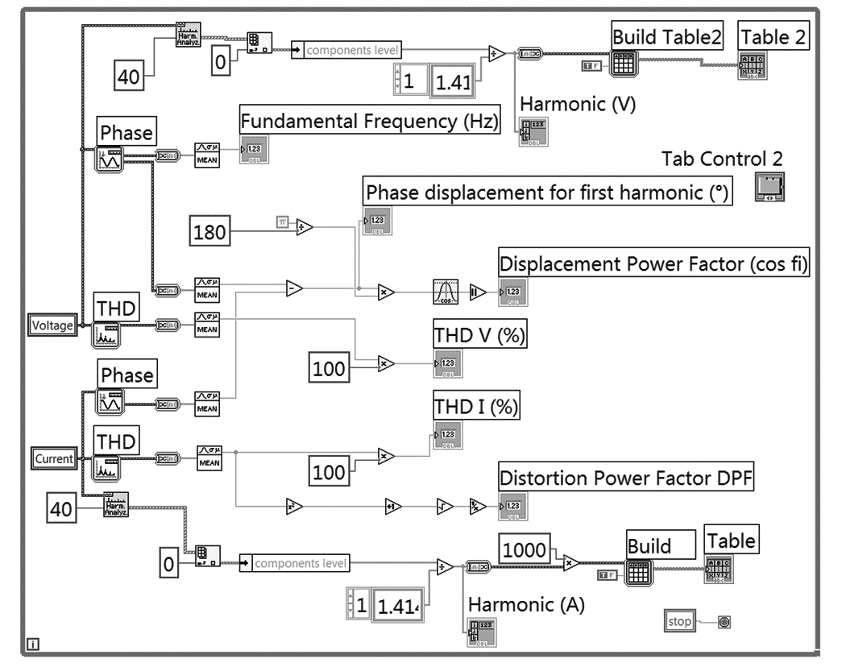

Fig. 4. Third thread of real-time application.

Application is capable for logging measured values and calculated parameters and events locally on hard disk drive. All measured and calculated parameters, transient analysis, as well as triggered events are stored at hard disk or other type of data storage. Data quantity and therefore measurement time, depends of storage capacity. Separate thread is responsible for network communication with user PC.

User interface virtual instrument is implemented in National Instruments LabVIEW developing package, which provides simple creation of virtual instruments[12], [13]. Virtual instrument is application running on general purpose operating system (GPOS) such as Microsoft Windows, Linux or MacOS, connected with RTOS over network. It consists of interface to real-time application and graphic user interface. Communication between user interface and real-time application is implemented using TCP/IP protocol.

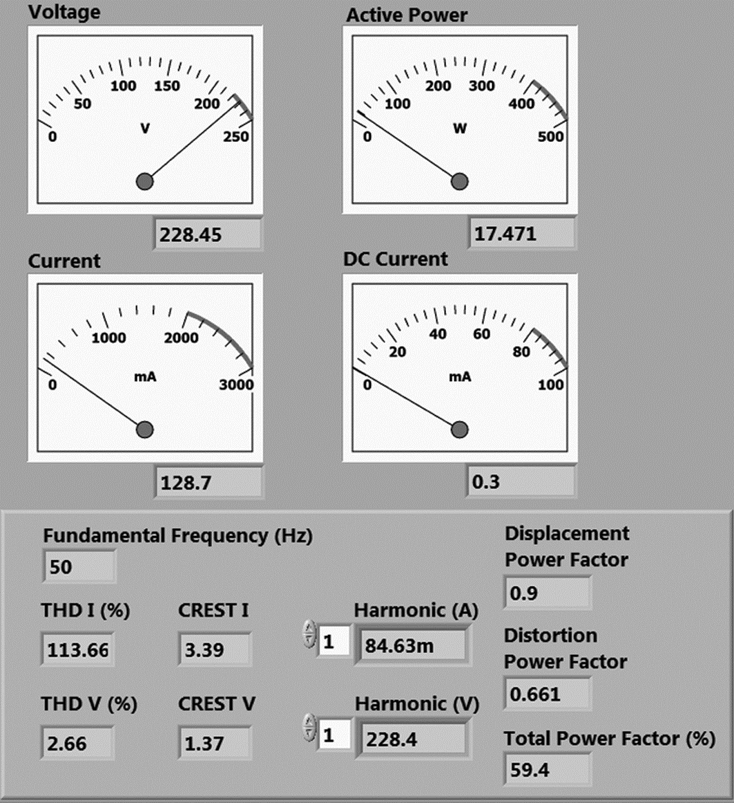

Fig. 5. Virtual instrument in one phase operation mode shows characteristics of CFL with poor distortion correction, with nominal real power of 18 W. Cos(φ) is 90%, current *THD* is 113.66%, voltage *THD* is 2.66% and *PF* 59.4%.

The user interface of the virtual instrument consists of visual indicators. It provides basic functions for measurement. The indicators – gauges and graphs – show measured values. User interface also provides controls for data manipulation and saving measured values (Fig. 5).

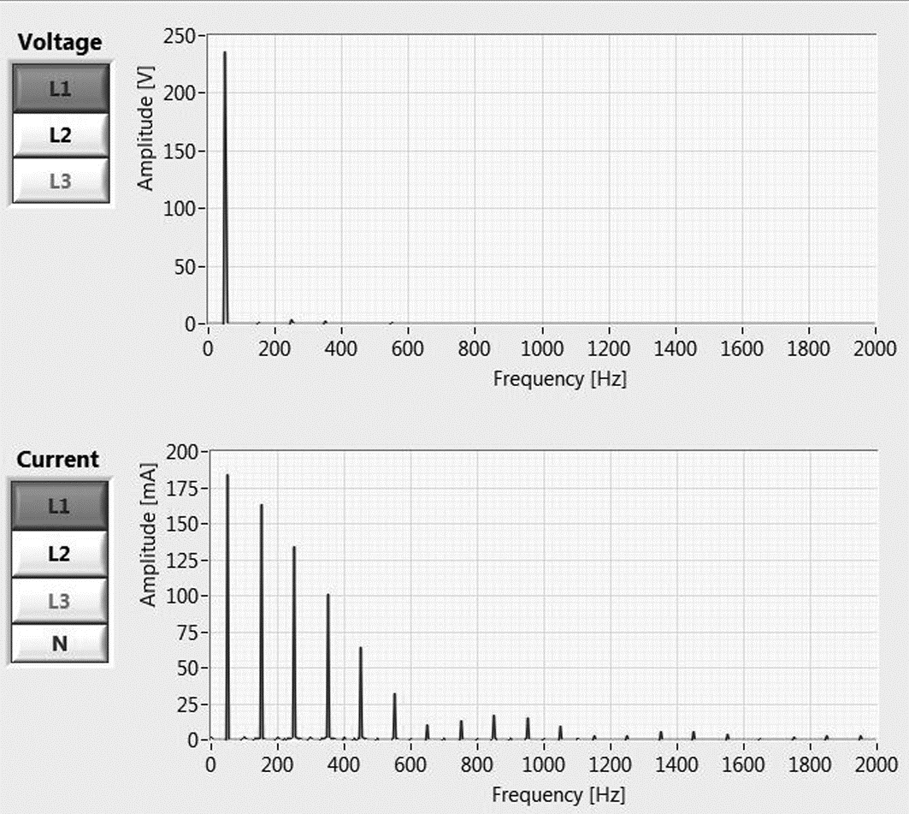

Fig. 6. Virtual instrument shows voltage and current spectra for L1 phase

Virtual instrument shows waveforms and spectra of measured voltages and currents (Fig. 6 and 7). Measured electrical quantities such as RMS and DC values, as well as calculated power quantities are shown in the front panel using virtual gauges and numeric indicators. Power factor and other power quality parameters are shown numerically. Virtual instrument can operate in one phase or three phase mode.

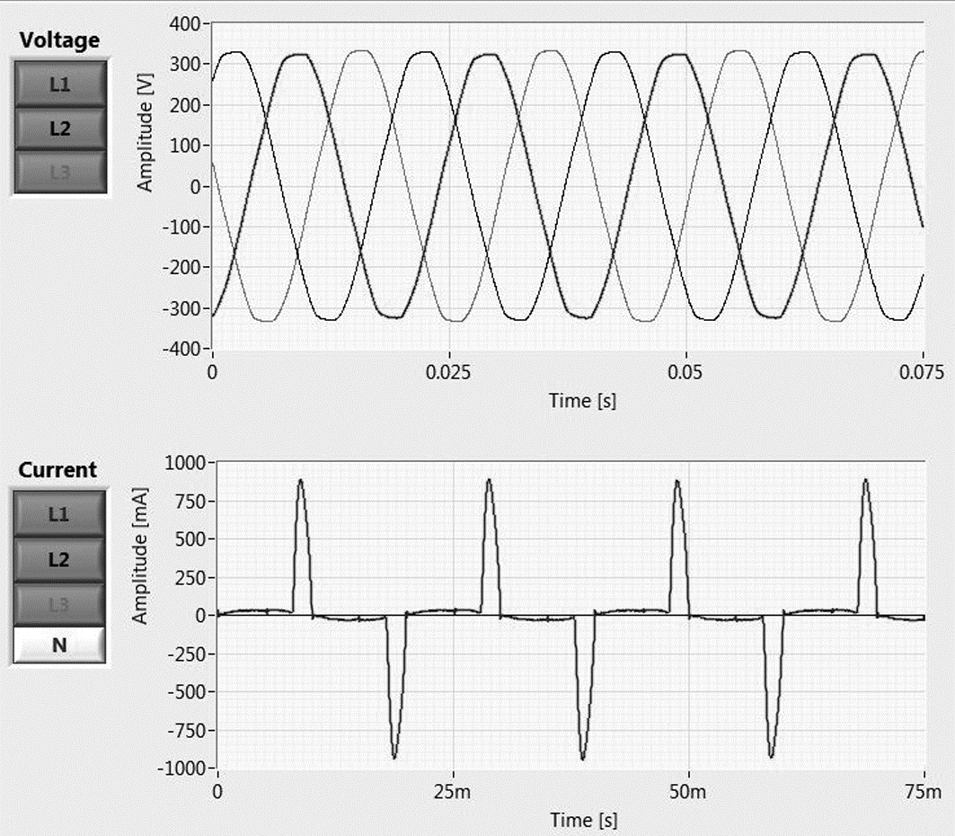

Fig. 7. Voltage and current waveforms for all phases

Harmonic magnitudes are shown in table and each magnitude can be represented separately.

Industrial PCs and PXI controllers have multicore architectures with sufficient processor power and operating memory capacity to support hardware virtualization. Operating system which hosts user interface can be executed concurrently with RTOS in real-time hypervisor [14].

## Reference

1. H. W. Beaty, D. G. Fink, Standard handbook for electrical engineers (McGraw-Hill, New York, 2007).
2. John G. Webster, The Measurement Instrumentation and Sensors Handbook (CRC Press, 1999).
3. T. H. Tumiran, M. Dultudes, The Effect Of Harmonic Distortion To Power Factor, Proceedings of the International Conference on Electrical Engineering and Informatics, 2007, pp. 834–837 Institute Teknologi Bandung, Indonesia
4. G. Moschopoulos, Single-Phase Single-Stage Power-Factor-Corrected Converter Topologies, IEEE Trans. on Industrial Electronics 52, 2005, pp. 23–35.
5. M. F. Mohammed, B. Ismail, I. Daut, S. Taib, S. Zakaria, Effects Of Appliances To Voltage, Current, Power Factor And Harmonic Distortion, Jurnal Penyelidikan dan Pendidikan Kejuruteraan, vol. 1 no. 1, 2004, pp. 55–64.
6. M. A. Dimitrijević, V. B. Litovski, Power Factor and Distortion Measuring for Small Loads Using USB Acquisition Module, Journal of Circuits, Systems, and Computers (JCSC), Vol. 20, No. 5, August 2011.
7. IEEE Std 1459-2000 – Standard Definitons for the Measurement of Electric Power Quantities Under Sinusoidal, Nonsinusoidal, Balanced or Unbalanced Conditions (The Institute of Electrical and Electronics Engineers, 2000).
8. IEEE Std 1459-2010 – Revision Standard Definition for the Measurement of Electric Power Quantities Under Sinusoidal, Nonsinusoidal, Balanced or Unbalanced Conditions (The Institute of Electrical and Electronics Engineers, 2010).
9. National instruments cRIO-9151 Product Data Sheet, National Instruments, http://ni.com
10. National instruments NI-9225 Product Data Sheet, National Instruments, http://ni.com
11. National instruments NI-9227 Product Data Sheet, National Instruments, http://ni.com
12. LabVIEW™ 2010 Express User Manual, National Instruments, http://ni.com
13. LabVIEW™ 2010 Express Measurement Manual, National Instruments, http://ni.com
14. Real-Time Hypervisor for Windows, National Instruments, http://sine.ni.com/nips/cds/view/p/lang/en/nid/207302

## Objavljeni radovi

1.1 **(Zadatak 1.1) (kategorija M63)** Dimitrijević, M**.**, Jovanović, B.: „Određivanje THD faktora bazirano na integrisanim kolima Teradian 71M6533 i IMPEG“, Zbornik LV konferencije ETRAN, Banja Vrućica, Bosna i Hercegovina, 06.06.-09.06., 2011, EL 3.4, ISBN 978-86-80509-66-2

1.2 **(Zadatak 1.1)** **(kategorija M23)** Dimitrijević, M., Litovski, V.: „Power Factor and Distortion Measuring for Small Loads Using USB Acquisition Module“, Journal of Circuits Systems and Computers, World Scientific Publishing Co. Pte. Ltd., Singapore, DOI 10.1142/S0218126611007657, August, 2011, Vol. 20, No. 5, pp. 867-880, ISSN 0218-1266

1.3 **(Zadatak 1.1) (kategorija M63)** Dimitrijević, M., Litovski, V.: „Virtual Instrument for Three-Phase Power Quality Analysis,“ VIII Simposium on Industrial Electronics INDEL 2010, Banja Luka, Bosnia and Herzegovina, 04.11.-06.11., 2010, pp. 189-194, ISBN 978-99955-46-03-8

1.4 **(Zadatak 1.1) (kategorija M33)** Dimitrijević,M., Litovski, V.: „Computer Based Power Factor and Distortion Measuring for Small Loads,“ Proceedings of the Small Systems Simulation Symposium 2010, Niš, 12.02.-14.02., 2010, pp. 81-85, ISBN 987-86-6125-006-4